W228A/1204C, W228B/1204C



DUBLIN INSTITUTE OF TECHNOLOGY
_____________

DT228A/1 MSc in Computing
DT228B/1 MSc in Computing
______________

WINTER EXAMINATIONS 2015/2016
______________

Probability and Statistical Inference [Math9100]

Ms. deirdre Lawless
Dr. Deirdre Lillis
Mr. Conor sayles

Monday 18th January 9.30 a.m. – 11.30 a.m.

Two Hours

Instructions to candidates

Answer question one and one other question.

All questions carry equal marks.

1. |  | A researcher in nutrition is currently researching red meat purchases in Ireland. They have developed a theory as part of their research that there is a correlation between average number of hrs of TV watched per week and the average number of purchases of red meat per week. Further they theorize that there is a difference in the number of purchases based on gender. Traditionally a 5% cut-off level of statistical significance is used within the research domain. A dataset comprising 386 records has been collected by conducting a phone survey.
  Variables of concern in the dataset
  Name | Label | Values | Type
  Purchases | Number of red meat purchases last week |  | Scale
  Gender | Gender | 1=Male, 2=Female | Categorical
  TVHrs | Number of Hrs of TV watched last week |  | Scale
  ZPurchases | ZScore Number of purchases |  | Scale
  ZTVHrs | ZScore Number of Hrs TV Watched |  | Scale
 | (a) | Explain the steps that the researcher should take in developing and testing their hypotheses.  In your answer you should derive relevant hypotheses, discuss the concepts of statistical significance and the role probability plays in this, statistical power, Type I and Type II errors.  (15 marks)
 | (b) | Missing data, Outliers, Skewness and Kurtosis are issues of concern in statistical analysis.  Discuss what is involved in screening your data, the options available to address these issues and the consequences not dealing with these issues may have on the concepts discussed in part (a).  Illustrate your answer with reference to the statistics and graphs provided in Appendix A. From your answer you should conclude whether you parametric or non-parametric tests are suitable for use in this research.  (25 marks)
 | (c) | Based on your answer to part (a) and (b), using the results of the relevant test provided in Appendix A, interpret the correlation between number of hrs of TV watched and the number of red meat purchases and explain what can be concluded about this relationship.  (10 marks)

2. | (a) | The researcher decided to explore the relationship between the number of red meat purchases made, the average number of hrs of TV watched and gender.  The researcher first created a simple linear regression model including the standardised score for the average number of hrs of TV as a predictor variable for the standardised score for the number of red meat purchases made.  Explain what linear regression will allow the researcher to do and what in this context prediction means. Illustrate your answer by using the additional statistics provided in Appendix B to state the regression equation, interpret the model and assess the fit and usefulness of the model considering the coefficients, R², Adjusted R²and F statistic.  (20 marks)
 | (b) | Differences in the number of purchases based on gender have been found. Suppose the researcher has extended the model to include gender by incorporating a dummy variable dummyGender which has a value 0 for male and 1 for female.  Explain clearly why a dummy variable is needed before using the information provided in Appendix B to state the regression equation, interpret this second model for both males and females, assess its fit and compare it to the model created in part (a).  (18 marks)
 | (c) | Three major concerns for multiple linear regression are multicollinearity, normality of the residuals and outliers.  Explain these concerns and why they are important. Illustrate your answer with reference to the model created for part (b) using the information provided in Appendix B.  (12 marks)

3. |  | Explain clearly the objectives of exploratory factor analysis and principal component analysis. Explain the difference between them and when you would use each technique.  (10 marks)
The researcher in the case study provided collected additional variables about the type of TV watched. Each variable represents the number of hrs on average spent watching that type of TV weekly.
Variable Name | Label
TVdrama | Watch TV drama
TVgardening | Watch TV gardening
TVcook | Watch TV cooking
TVcomedy | Watch TV comedy
TVdocumentary | Watch TV documentaries
TVfilms | Watch TV films
TVdrama | Watch TV drama
TVnews | Watch TV news
TVcuraff | Watch TV current affairs

Discuss the suitability of the dataset and the reliability of the scale for use in exploratory factor analysis. Illustrate your answer with reference to the additional statistics and graphs provided in Appendix C.
(15 marks)
Suppose the researcher conducted an Exploratory Factor Analysis on these variables using Principal Axis Factoring as the extraction method and Varimax as the rotation.

Explain how factor analysis works focusing on extraction and loading. Illustrate your answer by interpreting the output of the factor analysis conducted for this research using the information provided in Appendix C.
(25 marks)

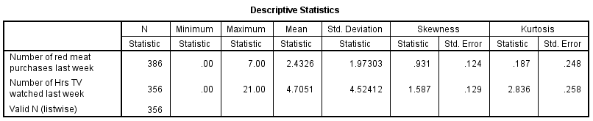  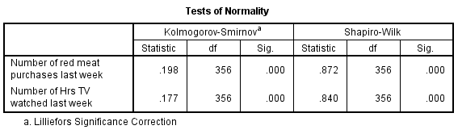 |  | 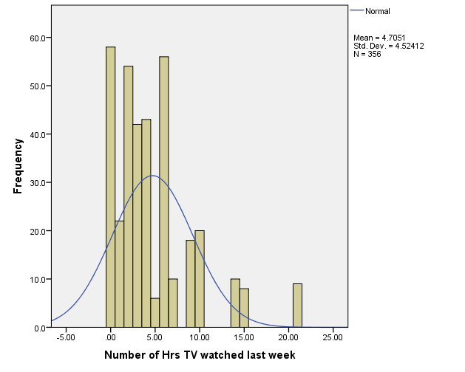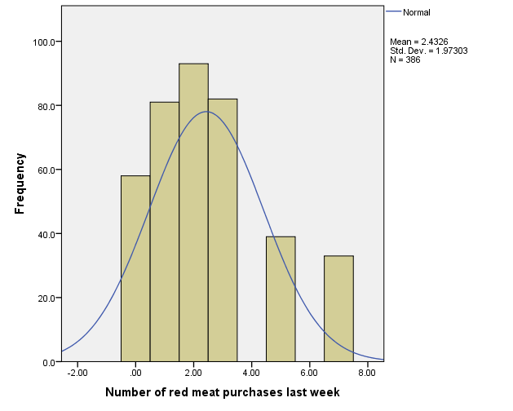
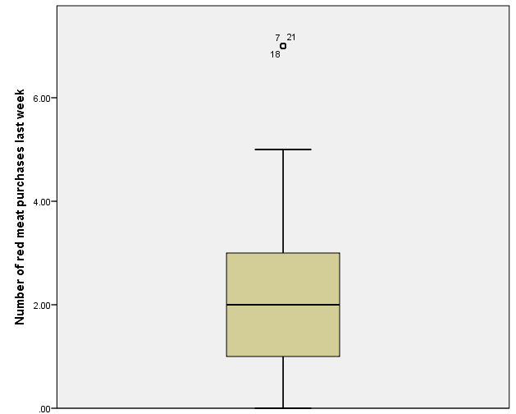 | 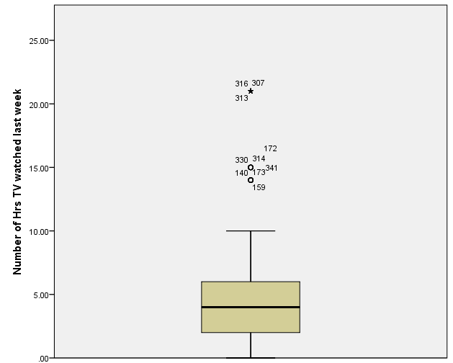
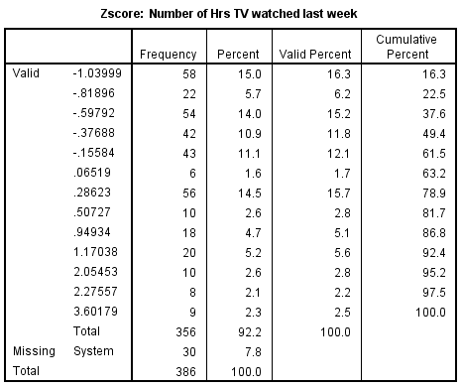 |  | 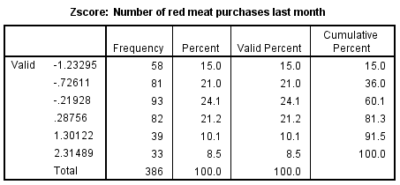

Missing Value Analysis  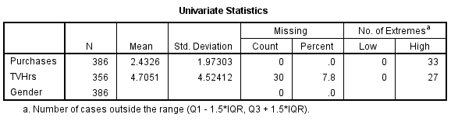 | 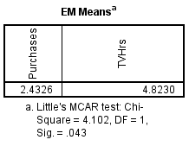 | 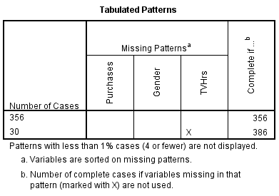
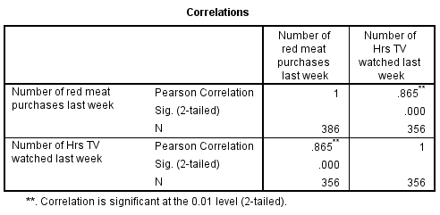 | 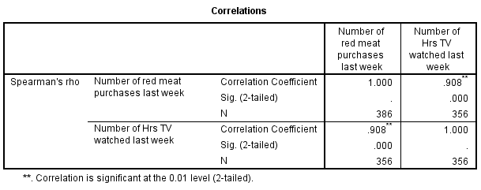

Model for Q2(a) |  | Model for Q2(b)
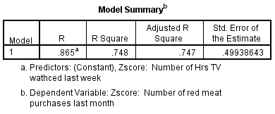 |  | 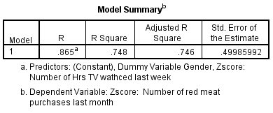
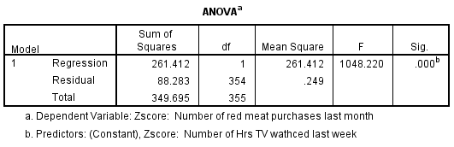 |  | 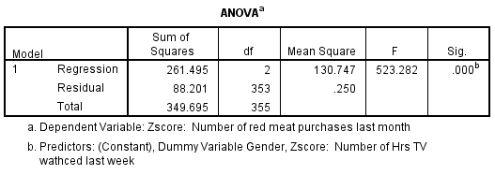
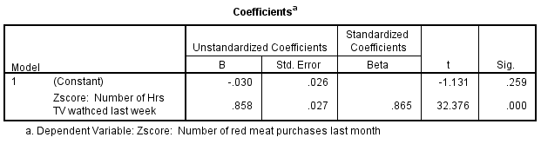
 | 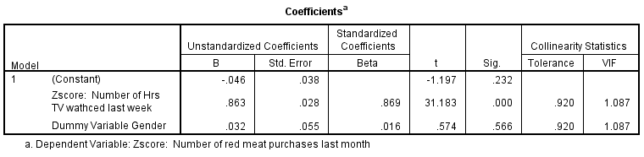
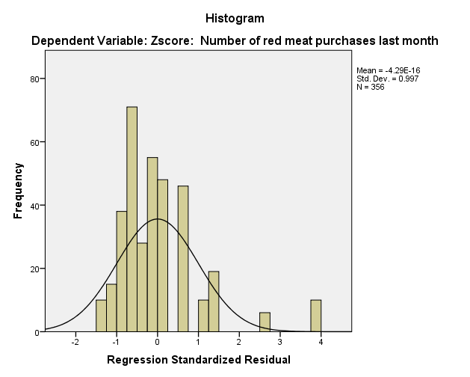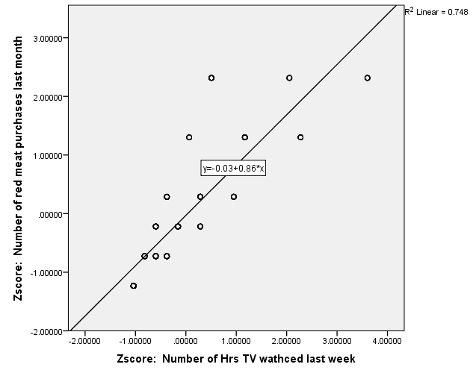 |  |  | 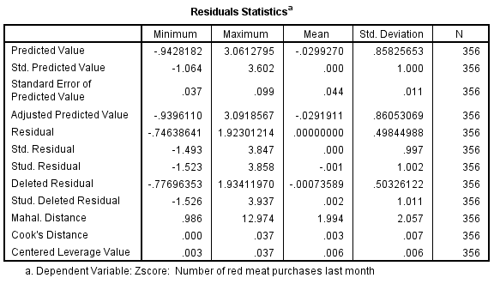
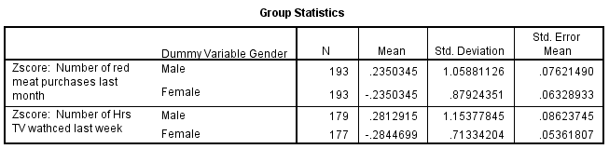

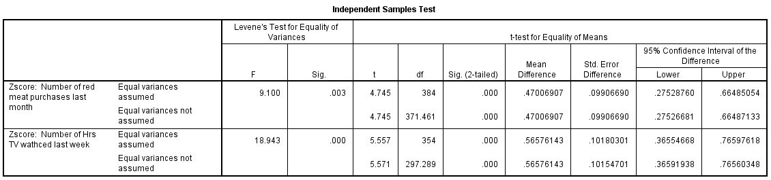

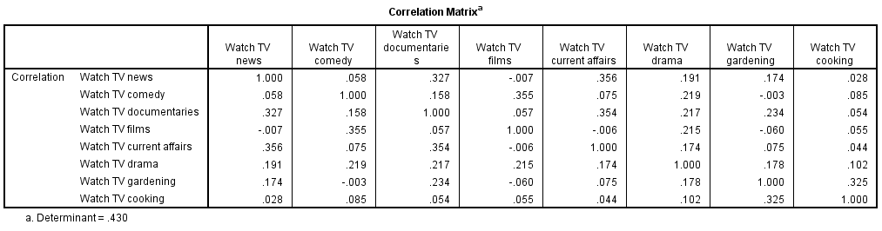 |  | 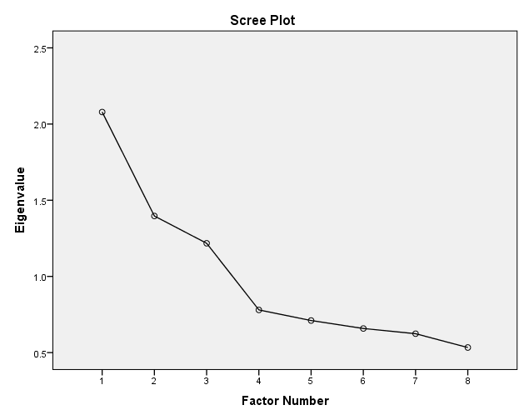
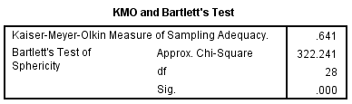  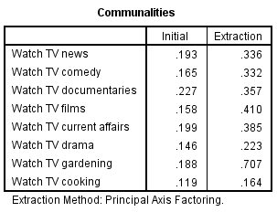 | 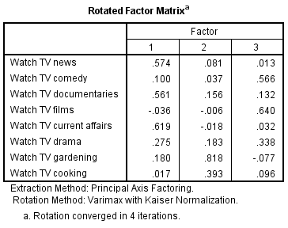 | 